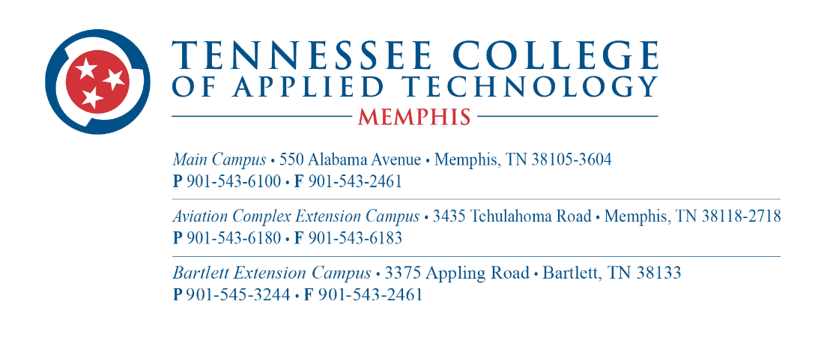

AVIATION MECHANICS INSTRUCTOR

The Tennessee College of Applied Technology-Memphis is accepting applications for the position of Aircraft Mechanics Instructor to teach at the extension campus.

Minimum Qualifications:
• A diploma in Aircraft Mechanics is required, and an associate's degree preferred
• Must possess a current A & P License
• Must possess good organizational and communications skills
• Must have the ability to interact well with students and coworkers
• Must show evidence of good character, mature attitude, and stable personality
• Must possess good computer skills
• Must have the ability to complete reports/paperwork and meet deadlines

Responsibilities and Duties:
• Possess a strong background in aviation-related math, aircraft hardware, material
processes, hand tools, regulations, weight and balance, aircraft blueprints, schematics &
graphics
• Instruct, monitor, grade, and evaluate individual students' progress
• Maintain appropriate records and submit timely reports
• Assist in the recruitment and placement of students
• Maintain good public relations with business and industry partners
• Develop and maintain a strong program advisory committee

Application Procedure:
• Applicants must submit an application. The application is found on the
college's website https://tcatmemphis.edu/about/jobs-and-employment
• The application must include at least three (3) professional references
• Current federal law requires identification and eligibility verification prior to employment
• Only U.S. citizens and aliens authorized to work in the United States may be employed

NOTICE OF NON-DISCRIMINATION: TN College of Applied Technology Memphis does not discriminate on the basis of race, color, religion, creed, ethnic or national origin, sex, disability, age status as a protected veteran or any other class protected by Federal or State laws and regulations and by Tennessee Board of Regents policies with respect to employment, programs, and activities.
The following person has been designated to handle inquiries regarding non-discrimination policies: Name and/or title: Sherlita Nelson-Denton, Email:sherlita.denton@tcatmemphis.edu, Address: 550 Alabama Avenue, Memphis, TN 38105, Telephone no. 901-543-6137.

The TN College of Applied Technology Memphis policy on nondiscrimination can be found at https://tcatmemphis.edu/about/non-discrimination-statement

