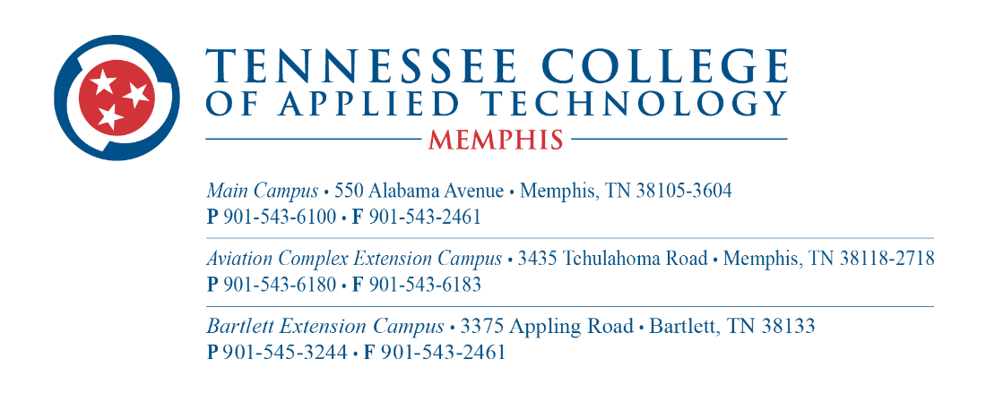

Job Announcement: Certified Nursing Assistant Instructor
Position Overview:
We are currently seeking a passionate and qualified individual to serve as a Certified Nursing Assistant Instructor. The successful candidate will be responsible for delivering comprehensive instruction in accordance with state-approved curriculum guidelines, fostering a supportive and engaging learning environment, and preparing students for success in their careers as Certified Nursing Assistants. Classes will be offered during the day and evening, beginning in Summer 2024.
Responsibilities:
- Develop and deliver instructional materials and lesson plans that align with state-approved curriculum standards and learning objectives.
- Provide hands-on training and demonstrations in clinical skills such as patient care, vital signs monitoring, infection control, and patient hygiene.
- Facilitate classroom discussions, group activities, and interactive learning experiences to enhance student understanding and retention of course content.
- Assess student performance through exams, quizzes, skills assessments, and other evaluation methods, providing constructive feedback and support for improvement.
- Collaborate with colleagues and healthcare professionals to enhance the quality of instruction and promote student success.
- Maintain accurate records of student attendance, grades, and progress, ensuring compliance with institutional and regulatory requirements.
- Participate in faculty meetings, professional development activities, and other initiatives to support continuous improvement and innovation in the CNA program.
Qualifications:
- Current licensure as a Registered Nurse (RN) or Licensed Practical Nurse (LPN) in the state of Tennessee.
- Minimum of two years of recent clinical experience working as a nurse in a healthcare setting, and two years of experience in long-term care.
- Certification as a Certified Nursing Assistant Instructor.
- Strong knowledge of nursing principles, practices, and procedures, with the ability to effectively teach and demonstrate clinical skills to students.
- Excellent communication and interpersonal skills, with the ability to engage and motivate students from diverse backgrounds.
- Demonstrated commitment to fostering an inclusive and supportive learning environment that promotes student success.
- Proficiency in using technology and educational tools to enhance instruction and facilitate learning outcomes.
- Ability to work collaboratively with colleagues, administrators, and industry partners to achieve program goals and objectives.
Application Process:
Interested candidates are invited to visit https://tcatmemphis.edu/about/jobs-and-employment to complete the application process.
Join our team and make a difference in the lives of aspiring healthcare professionals!

