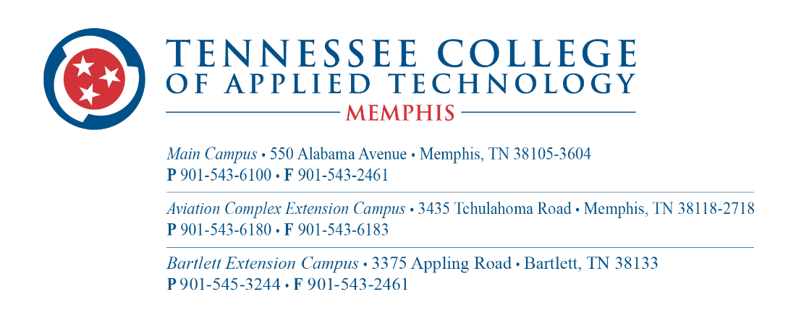

**Job Announcement: Phlebotomy Instructor**

**Position Overview:**

As a Phlebotomy Instructor, you will play a pivotal role in educating and training aspiring phlebotomists. The successful candidate will be responsible for planning and delivering comprehensive instruction in phlebotomy techniques, laboratory safety, specimen handling, and related topics. This position offers an exciting opportunity to contribute to the success of our students and make a meaningful impact on their future careers in healthcare.

**Key Responsibilities:**

* Implement curriculum for phlebotomy courses in alignment with program objectives and industry standards.
* Deliver engaging lectures, demonstrations, and hands-on training sessions to facilitate student learning and skill development.
* Provide constructive feedback, guidance, and support to students to enhance their understanding and proficiency in phlebotomy procedures.
* Create a positive and inclusive learning environment that promotes student participation, collaboration, and success.
* Assess student progress through assignments, exams, and practical evaluations, and maintain accurate records of student performance.
* Stay current with advancements in phlebotomy practices, technology, and regulations to ensure the program remains relevant and up-to-date.

**Qualifications:**

* Bachelor's degree in a relevant field preferred; Associate's degree or equivalent experience required.
* Certified Phlebotomy Technician (CPT) credential or equivalent certification required.
* Minimum of 3 years of professional experience working as a phlebotomist in a clinical setting.
* Previous teaching or training experience preferred, particularly in adult education or vocational training.
* Strong communication, interpersonal, and organizational skills.
* Ability to work effectively with diverse groups of students and colleagues.

**Schedule:**

Tuesday through Thursday, 3:30 p.m. to 9:30 p.m. (In-person instruction)

Virtual Instruction: Mondays and Fridays

Application Procedure:

Interested candidates are invited to visit https://tcatmemphis.edu/about/jobs-and-employment to complete the application process.

Join our dynamic team and help shape the future of healthcare professionals. Apply today and be a part of our mission to empower students to achieve their career goals and make a difference in their communities.