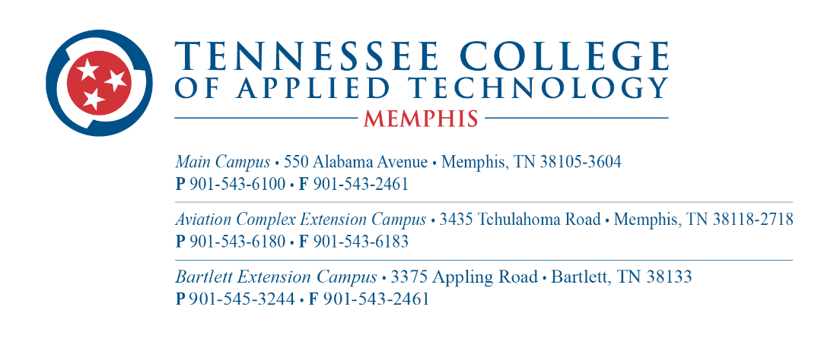

POSITION ANNOUNCEMENT
Electronic Technology
Instructor {Full-Time}

The Tennessee College of Applied Technology Memphis is accepting applications for a full-time Instructor for the Electronics Technology Program at our main campus located at 550 Alabama Avenue, Memphis, Tennessee 38105. This is a full-time position, Monday – Thursday, 7:30 a.m. – 3:30 p.m.

REQUIRED QUALIFICATIONS:
- Associate Degree in Electronics Technology or related area
- A minimum of (5) years of full-time, documented industry experience
- Bachelor’s degree with a concentration in Electronics Technology or related area plus (5) five years of full-time industry experience preferred.
- Ability to work with a diverse population
- Excellent verbal and written communication skills required.

GENERAL DUTIES:
- Provide individualized theory and hands-on instruction
- Deliver instruction using a variety of methods, including on-site and online
- Maintain the Electronic Technology program by keeping the curriculum current with employer expectations.
- Give guidance to the students as they complete their lab assignments, demonstrating their skills in routine maintenance, troubleshooting, and problem-solving
- Knowledgeable in electronic equipment, electronics, robotics, PLCs, motors and controllers, and basic computer networking
- Monitor grades and evaluate individual student progress.
- Mentor and advise students
- Maintain consistent communication with students through office hours, email, and telephone
- Plan, develop, and deliver curriculum
- Support the mission, vision, and core values of TCAT-Memphis
- Engage in professional development activities
- Promote diversity and cultural competency
- Assist in the recruitment and placement of students
- Maintain an industrial advisory committee
- Maintain good relationships with business and industry partners
- Uphold records of student attendance, student progress, departmental supplies, departmental equipment, and others
- Perform other duties as assigned by the President and Vice President
Salary: Commensurate with education and experience.

Application Deadline: Review of applications will begin immediately, and applications will be accepted until position is filled.

Please complete the following steps to apply:
- Visit https://tcatmemphis.edu/about/jobs-and-employment
- Select "View Open Job Opportunities"
- Select "PageUp Job Postings"
- On the left pane menu, under college, select TCAT Memphis and follow the instructions
Tennessee College of Applied Technology Memphis does not discriminate on the basis of race, color, religion, ethnic or national origin, sex, disability, age, status as a covered veteran, or genetic information in its programs and activities. The following person has been designated to handle inquiries regarding the nondiscrimination policies: Sherlita Nelson-Denton (901-543-6137) or via this webpage: http://www.tcatmemphis.edu.

.

