

MPP / Staff Position Description

|  |  |
| --- | --- |
| **HUMAN RESOURCES USE ONLY** | |
| **Conflict of Interest (COI) Designated:** ☐ Yes ☒ No  **Mandated Reporter:** ☒ Limited ☐ General ☐ N/A  **Review Date:** | ***MPP Positions Only***  **MPP Job Code:** B 01 4  **Job Family:** Business Operations  **Job Function:** General Administration  **Job Category:** Director |

**Mandated Reporter Per CANRA** ☒  **YES** ☐  **NO**

The person holding this position is considered a ‘mandated reporter,’ under the California Child Abuse and Neglect Reporting Act (CANRA) and is required to comply with the requirements set forth in CSU Executive Order 1083 as a condition of employment.

**Please Note**: A current and accurate signed Position Description is required for each MPP / Staff position and must be on file in the Center for Human Resources. After completion, the Position Description should be reviewed, signed and dated by the employee, the supervisor and the Center for Human Resources - Classification and Compensation.

|  |  |  |
| --- | --- | --- |
| **Please check one:** | ☐ New Position | ☒ Existing Position Update |

|  |  |
| --- | --- |
| **Date:** |  |
| **Department & Division:** | Logistical Services, Business and Financial Affairs |
| **Employee Name**  *(leave blank if vacant)***:** |  |
| **Current Classification & Grade:** | Administrator ll, Grade 1 |
| **FLSA Status:**  *(exempt or non-exempt)* | Exempt |
| **Working Title:** | Director, Logistical Services |
| **Position Number & Job Code:** | 10001454, 3312 |
| **Working Title & Position Number of HEERA Designated Appropriate Administrator:** | Associate Vice President, Business Operations, 10001012 |

**I. FUNCTION OF THE EMPLOYING UNIT:**

*State the basic purpose of the Department/Unit in one brief paragraph. Include the division’s DEI statement here.*

Logistical Services is comprised of Material Management, Shipping & Receiving Services, and Mail Services, and is responsible for providing service to the campus in each of these respective areas.

The Division of Business and Financial Affairs (BFA) celebrates diverse backgrounds and perspectives. We understand representation is essential to our success, which is why we strive to recruit and retain highly-skilled, compassionate leaders. By prioritizing listening and learning, engaging in critical conversations, and thoughtfully considering the needs of our different populations, we are creating a culture of belonging. As a division, we aim to offer opportunities for advancement and foster an inclusive environment, so all are valued and empowered to thrive.

**II. PURPOSE OF POSITION**:

*State the basic purpose of the position in one to three specific statements.*

Under direction of the Associate Vice President of Business Operations, the incumbent shall be responsible for the division’s administration and management of personnel of Mail Services, Shipping & Receiving, and Material Management. The incumbent supervises and manages personnel, conducts performance evaluations, and inspects completed work; makes recommendations for counseling, reprimands, and promotions.

Members of the Logistical Services management team shall promote and maintain a safe, inclusive environment for all staff and foster a diverse community that is free of harassment. As a member of the Logistical Services management team and SDSU’s administration, incumbent works with various constituencies to improve services and resolve problems; maintains continuing contact with faculty, staff, students, campus administrators and service providers to identify needs and expectations, coordinates services and support, and determines the level of customer satisfaction with the services provided. The Director works with and through other people to accomplish the objectives of the organization and its members and represents the department to all levels of the campus. The Director is responsible for assessing issues and situations, defining goals and objectives, developing strategies to achieve the goals and objectives, determining the required resources, organizing, directing, and controlling the activities required to attain the goals, and motivating staff to achieve results. The Director is responsible for the selection, training and evaluation of staff, delegates and assigns their work; provides leadership and encouragement of growth.

*The person holding this position is considered a ‘mandated reporter’ under the California Child Abuse and Neglect Reporting Act and is required to comply with the requirements set forth in CSU Executive Order 1083 as a condition of employment.*

**III. CHANGES IN RESPONSIBILITIES**

**IV. MAJOR RESPONSIBILITIES**:

*Clearly list the major responsibilities/essential functions in descending order from the most important to the least important. Indicate the approximate percentage of time spent in each (percentages should not be less than 5%). The percentage must total 100%.*

| **Description of Responsibilities:** | **(%) Percent of Time** |
| --- | --- |
| * **Department Supervision**   Cultivates positive working attitudes and maintains work environment by ensuring delivery of high quality service, as well as planning, scheduling and monitoring work in progress; resolving employee behavioral problems through constructive communication and progressive discipline; keeping – Associate Vice President of Business Operations apprised of any relevant employee issues; ensuring employees maintain satisfactory levels of attendance and punctuality; ensuring maintenance of accurate attendance records; completing timely, accurate and fair employee evaluations; interviewing and evaluating job applicants; preparing in-depth analysis of department operations procedures and policies; conducting staff meetings on a regular basis. | 30% |
| * **Department Operations**   Administers the operational aspects of Logistical Services, coordinating it with all facets of the institution. Responsible for cost-effective operations within Mail Services, Shipping and Receiving and Material Management. Develop department policy and procedures, evaluates effectiveness of services and develops and recommends methods of improvement or expansion of services. Oversee the day-to-day operations. Conduct timely and constructive evaluations of staff performance. | 20% |
| * **Planning and Organizing**   Plans and organizes Mail Services, Shipping & Receiving and Material Management services by ensuring all departmental operations, procedures and related reports are performed in accordance with established guidelines and timeframes; analyzing services required by the University which are not currently offered; researching and recommending changes in services and procedures; preparing in-depth analysis of department operating procedures and policies; presenting reports with reliable recommendations and conclusions; preparing and monitoring department budgets, income and expenditure reports; ensuring that billings are prepared accurately and in a timely manner; producing high quality logs and reports which meet the objectives of the users, are easily maintained by other supervisors; producing reports and studies which describe user needs, alternative approaches to meeting those needs, an analyzing of the costs of alternatives and recommendations for the automations approach. Creating and implementing plans to streamline transportation and distribution. | 20% |
| * **Customer Service**   A passion for customer satisfaction. Responsible for the delivery of cost estimates, job planning and addressing of customer concerns or complaints; maintaining job schedules and commitments; answering customer inquiries or complaints related to services; and acting as liaison between department customers and contracted services ensuring timely completions of work or service and resolutions of the problems. Develop and implement customer services policies and procedures. | 15% |
| * **Management and Professional Leadership**   Provides management and leadership resources to Mail Services,  Shipping and Receiving, and Material Management  Staff by ensuring adherence to University policies and procedures;  Empowering staff to provide continuous process and quality  Improvements; developing and maintain effective working relation-  Ships with University departments; providing quality training and  and information to users and acting as a resource for problem  determination and correction; overseeing and resolving operational  problems; keeping senior administrators informed of department  progress; and maintain a customer-oriented environment. | 10% |
| * **Other**   Performs other related tasks as required. Through long-range planning processes, provides recommendations for appropriate development of all facts of Logistical Services in support of goals of the university. Active participation in the Campus Disaster Preparedness Plan is required. | 5% |
| **Total**  **=100%** | 100% |

**V. LEAD WORK DIRECTION OVER OTHERS**:

*List of individuals the incumbent supervises/leads. Indicate the type of supervision, whether direct (directly supervises the position and conducts performance evaluation) or general (acting in a lead capacity or assigning work).*

|  |  |  |
| --- | --- | --- |
| **Classification** | **Working Title** | **Type of work direction**  **(Direct or General)** |
| John Zuzarte | Assistant Director | General |
| Jeffrey Seabrook | Info. Tech Consultant, Career | General |
|  |  |  |

**VI.** **POSITION REQUIREMENTS**:

*A. List education and years of experience required that are based on the classification standards.*

A bachelor’s degree in business administration, public administration or a related degree is preferred but consideration will be given to candidates with an equivalent combination of education and relevant experience and training which demonstrates the ability to perform the duties and responsibilities of the position; three years of progressively responsible experience in management or supervision of a large warehouse shipping and receiving department or similar environment, preferably in a college or university setting. Demonstrated experience and effective supervisory and leadership skills in directing and managing a diverse work force involved in the delivery of Logistical Services (mail distributions, shipping and receiving, material management, etc.).

These qualifications would normally be obtained through a high school program, technical/vocational program, or their equivalents combined with several years of related office work experience.

*B. Skills, knowledge, and abilities required for this position that are based on the classification standards*

* Thorough knowledge of department operations and workflow to allow judgment to plan and schedule stages of receipt, processing, storage, and distributing of materials and mail; ability to project completion dates.
* Knowledge of accounting, storage, record keeping, inventory methods, and procedures for warehousing functions associated with shipping and receiving, mail distributions, and materials management.
* Knowledge and skill in the preparation, administration, and financial analysis of departmental budgets.
* Working knowledge of warehousing and distribution methods.
* Knowledge of hazardous material regulations.
* Thorough knowledge of safety practices and measures required in the operation of warehouse operations in a university or similar environment.
* Thorough knowledge of effective supervisory principals, practices, techniques, and effective work policies, practices, and procedures.
* Requires the ability to resolve customer inquiries or complaints in a tactful, diplomatic, timely, and cost-effective manner.
* Excellent organizational and planning skills, ability to prioritize and meet deadlines.
* Must have ability to supervise and provide sound judgment and leadership to a large multi-functional staff involved in the combined warehouse operations and activities in a major university setting and a bargaining unit environment.
* Must have ability to provide supervision and individual work direction, train others in proper work methods and safety practices, communicate performance standards and provide feedback on work performance; take corrective and disciplinary action as required and as appropriate.
* Must have ability to understand, interpret, apply, and convey to others university and departmental policies and procedures.
* Must demonstrate initiative and have the ability to act independently to resolve problems, meet deadlines and ensure continuity of operations; must have ability to recognize the need to take action.
* Ability to form cooperative relationships; excellent verbal and written communications skills; ability to use tact and diplomacy while exercising good judgment with individuals at all levels in person, in writing, by telephone and through electronic means.
* Must be able to analyze management data, evaluate productivity, and to plan operational requirements including expense plans for personnel/staffing, overtime, purchasing of materials & equipment, training, etc., while ensuring budget goals are maintained.
* Ability to represent Logistical Services at meetings and on committees.
* Ability to interpret and apply collecting bargaining unit agreement.
* Ability to operate a personal computer using various software applications.
* Demonstrated ability to be proactive and creative in order to maintain productivity, reduce costs, and provide outstanding service.
* Organizational skills to prioritizing assignments, set goals, and project department needs, while meetings deadlines; ability to manage multiple projects and responsibilities at the same time.

*C. Specialized skills required for this position*

*D. License and Certification Required (I.e., Driver’s License and Grade, Certification, etc.)*

N/A

**VII.** **PREFERRED QUALIFICATIONS**:

* College degree in related field.
* Experience with SDSU policies and procedures.
* Knowledge and experience working in a collective bargaining environment including conflict resolution and grievance administration.
* Experience working in a business services/operations or logistics environment.
* Experience working in higher education

**VIII. SIGNATURES:**

*The signature indicates position description is an accurate and correct statement of duties and responsibilities assigned to the position. (Limited to 3 Signers as listed below)*

|  |  |  |
| --- | --- | --- |
|  |  |  |
| Incumbent’s Signature/Acknowledgment |  | Date |
|  | | |
|  |  |  |
| Appropriate Administrator Signature |  | Date |
|  | | |
|  |  |  |
| Classification & Compensation Services |  | Date |

# Attachment A

Complete for all positions

**To comply with the provisions of the Americans with Disabilities Act, specify the physical, mental, and environmental conditions of the essential functions of the job, please complete the sections below.**

**Physical Summary:** Choose one description out of the categories below that best describes this position.

☐  **Sedentary Work:** Involves mainly sitting. Walking and standing are minimal. Lifting is limited to lightweight objects (10 pounds or less).

☒  **Light Work:** Job involves some lifting of medium weight objects (10-20 pounds) and/or 10% -20% of the job involves standing or walking.

☐  **Medium Work:** Job **i**nvolves lifting heavy-weight objects (20-40 pounds) and/or 20%-40% of the job involves standing, squatting, kneeling, or walking. May require pushing or pulling objects within the weight limits.

☐  **Heavy Work:** Job involves lifting more than 40 pounds. Approximately half of the incumbent’s time will be spent walking, standing, squatting, kneeling, or climbing.

**Use the codes below for each of the items which most accurately describe the extent of the specific activity performed in this position.**

“C” = constantly or 6-8 hours per day “F” = frequently or 3-6 hours per day

“O” = occasionally or up to 3 hours per day “N” = never

|  |  |  |  |
| --- | --- | --- | --- |
| **Physical Requirements of the Position** | | **Mental Requirements of the Position** | |
| O | Bending (neck) | C | Reading & Comprehending |
| O | Bending (waist) | C | Writing |
| N | Climbing | O | Performing Calculations |
| N | Crawling | C | Communicating Orally |
| N | Kneeling | C | Reasoning & Analyzing |
| O | Pushing/Pulling | C | Decision Making |
| C | Sitting | O | Directing/Coordinating Others: |
| N | Squatting |  | Other: |
| C | Standing | **Environmental Working Conditions** | |
| O | Twisting (neck) | O | Exposure to variations in temperature/humidity |
| O | Twisting (waist) | O | Exposure to chemicals, gases, dust or fumes |
| C | Walking | O | Operates machinery or drives motorized equipment |
| O | Handling Objects | N | Exposure to bio-hazards |
| C | Manual dexterity | C | Working in normal office environment |
| O | Reach above/below shoulder | O | Working outside with various weather conditions |
| O | Using foot controls | N | Uses specialized equipment |
|  | Other: |  | Other: |

# Attachment B

Complete for all positions

***Sensitive Position:*** *For current employees who are voluntarily reassigned or reclassified to a sensitive position, a background check is also required. To determine if this position is a sensitive position, please consult with Human Resources and reference the* [*CSU Background Check Policy*](https://sdsuedu.sharepoint.com/sites/BFA/HR/employment/Pages/CSU-Background-Check-Policy.aspx).

|  |  |  |
| --- | --- | --- |
| *Consideration for designation as a sensitive position per HR Technical Letter 2017-17* | | |
| 1. Does this position have responsibility for the care, safety, and security of people (including children and minors), animals, and CSU property? | ☒ Yes ☐ No | Sexual offender registry check for those who perform work involving regular or direct contact with minor children and those who are identified as mandated reporters of child abuse and neglect under Executive Order 1083 and California Penal Code §11165.7(a). |
| 1. Does this position have access to and responsibility for detailed personally identifiable information about students, faculty, staff, or alumni that is protected, personal, or sensitive? | ☒ Yes ☐ No | Access to Level Protected Level 1 Data: (i.e., Passwords, DOB, Credit Card Numbers, SSN’s, Medical Data, Law Enforcement Records, etc.) - Link to or incorporate ICSUAM pages. |
| 1. Does this position have access to student records? | ☐ Yes ☒ No | FERPA (Access to student education records) |
| 1. Is the position responding for recording/reporting Clery Data? | ☐ Yes ☒ No | Clery Act Basics |
| 1. Does the position have access to protected health information? | ☐ Yes ☒ No | HIPAA |
| 1. Will this position be an active/participating member of the SDSU Emergency Operations Team? | ☒ Yes ☐ No | EOC Member |
| 1. Does this position have responsibility for operating commercial vehicles, machinery or equipment that could pose environmental hazards or cause injury, illness, or death? | ☐ Yes ☒ No | Motor Vehicle Records/Licensing Check is required. CA Defensive Driver |
| 1. Does the position influence or make decisions regarding real property, real property acquisitions and/or leaseholds, land use and/or development? | ☐ Yes ☒ No | COI CAT 1 |
| 1. Does the position influence or make decisions regarding the purchase of goods, service or construction work? **Note: Having a procurement card is not qualifying if the individual is limited to making directed and supervised purchases from established vendors.** | ☐ Yes ☒ No | COI CAT 2 |
| 1. Does the position influence or make decisions regarding the investment of **SDSU/CSU** funds? | ☐ Yes ☒ No | COI CAT 5 |
| 1. Does the position influence or make decisions regarding the sale of campus goods, services, products, or commodities (including agricultural commodities), which are sold by the campus? | ☐ Yes ☒ No | COI CAT 6 |

# Attachment C

Complete for **MPP Positions Only**

**Mental Effort:**

*Enter frequency of occurrence for all applicable activities using the following key:*

**1=Never Occurs 2=Seldom Occurs 3=Sometimes Occurs 4=Occurs Often 5=Almost Always Occurs**

|  |  |  |  |
| --- | --- | --- | --- |
| **Planning** | | **Staffing** | |
| 3 | Forecast | 5 | Define Roles |
| 4 | Set Program Goals | 5 | Give Input to Position Descriptions |
| 2 | Determine Budget Allocations | 5 | Determine Selection Criteria |
| 5 | Establish, Implement, Revise Policies | 5 | Recruit/Interview/Select |
|  |  | 5 | Orient Staff |
| **Organization** | | **Employee Relations** | |
| 3 | Describe Relationships Between Functions | 2 | Initiate Corrective Action |
| 3 | Define Department/Divisional Structure | 1 | Authorize Formal Discipline |
| 5 | Establish Priorities to Meet Goals | 5 | Administer Collective Bargaining Agreements |
| 4 | Schedule Work for Employees | 2 | Prepares/Investigates Grievance Awards and Complaints |
| 5 | Implement procedures | 2 | Formulates/Represents University Position for Formal Grievances/Complaints |
| 5 | Determine work methods |  |  |
| 5 | Balance multiple tasks/projects |  |  |
| **Direction/Leadership/Supervision** | | **Performance Evaluations** | |
| 4 | Educate | 5 | Determine Performance Standards |
| 4 | Delegate | 1 | Authorize/Approve Awards |
| 5 | Coordinate | 5 | Prepare Performance Evaluations |
| 5 | Coach/Train/Develop | 5 | Observe/Follow-Up on a Daily Basis |
| 5 | Recommend Formal Training | 3 | Correct Work/Behavior Problems |
| 5 | Motivate |  |  |
| 5 | Instruct/Demonstrate |  |  |
| 4 | Schedule Staff/Readjust Schedule |  |  |
| **Organization** | | **Other** | |
| 3 | Describe Relationships Between Functions |  |  |
| 3 | Define Department/Divisional Structure |  |  |
| 5 | Establish Priorities to Meet Goals |  |  |
| 4 | Schedule Work for Employees |  |  |
| 5 | Establish deadlines |  |  |
| 5 | Implement procedures |  |  |
| 4 | Determine work methods |  |  |
| 5 | Balance multiple tasks/projects |  |  |

**MPP Job Code:**

|  |  |  |
| --- | --- | --- |
|  |  |  |
|  |  |  |

# Attachment D

Department Organization Chart

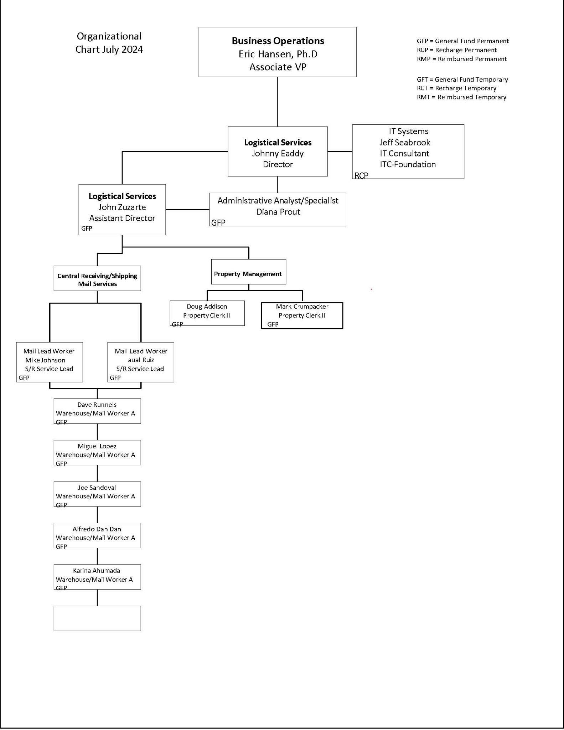**Instruction:** Please insert an image of your department’s organization chart and highlight where this Position Description falls within the chart.